[E138] Rock switch

Unscrew the strain relief lock nut.

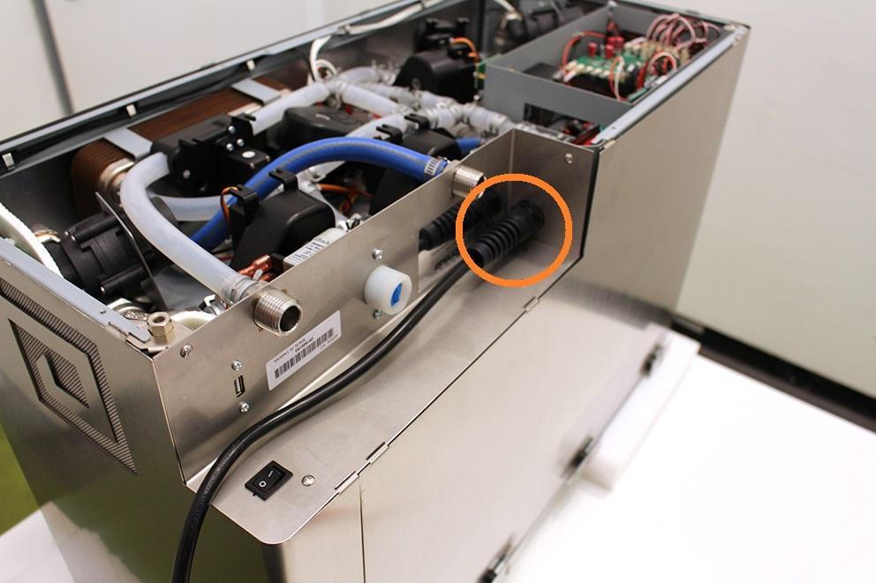

Remove the wort outlet hose clamp, pull off the wort outlet silicone tube and unscrew the indicated screws.

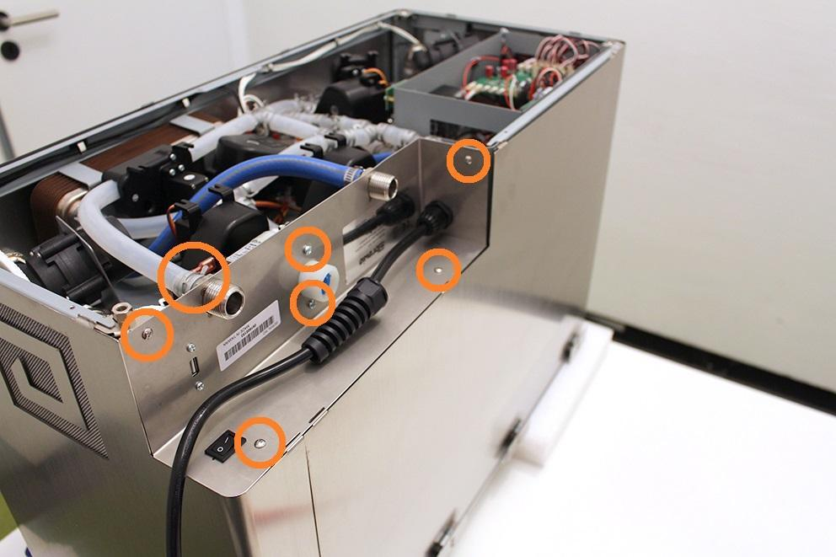

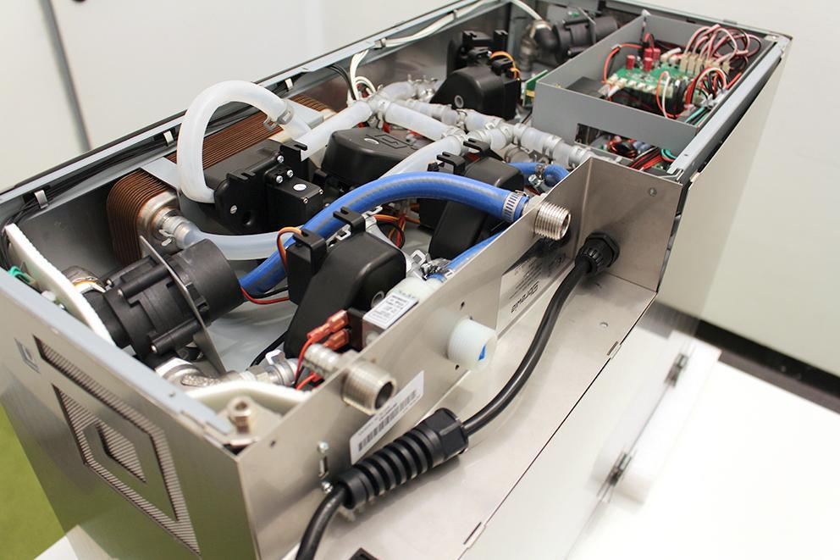

Remove the heat insulator.

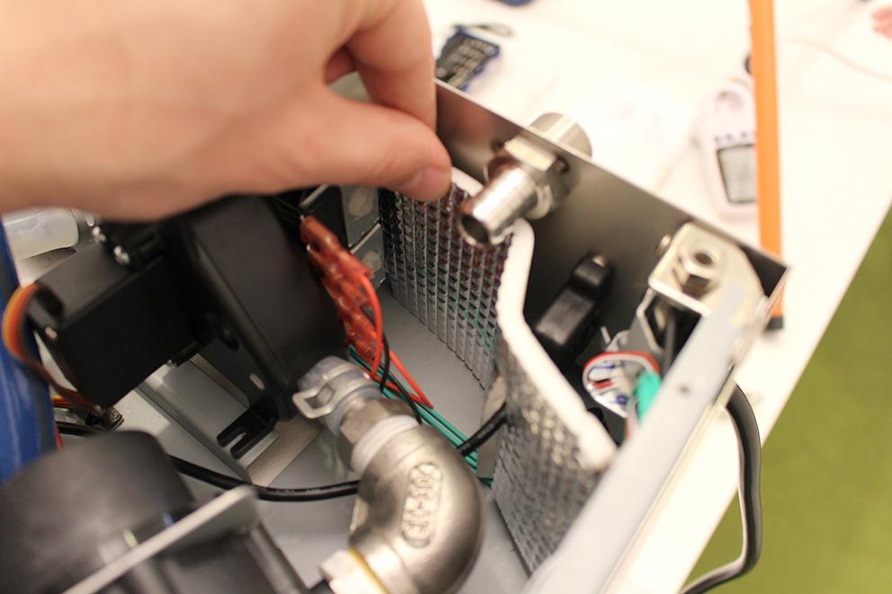

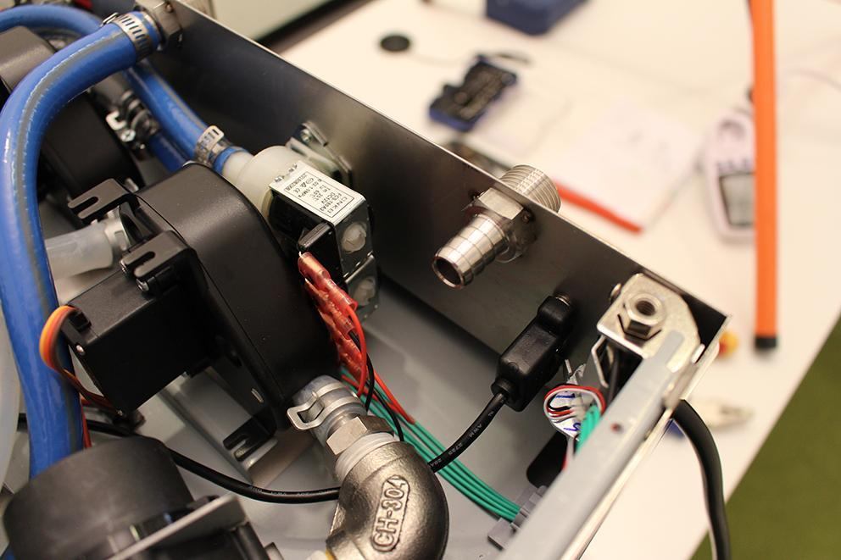

Remove the USB plug. Make sure that the washers dont fall under the assembling plate. Use magnet for this step.

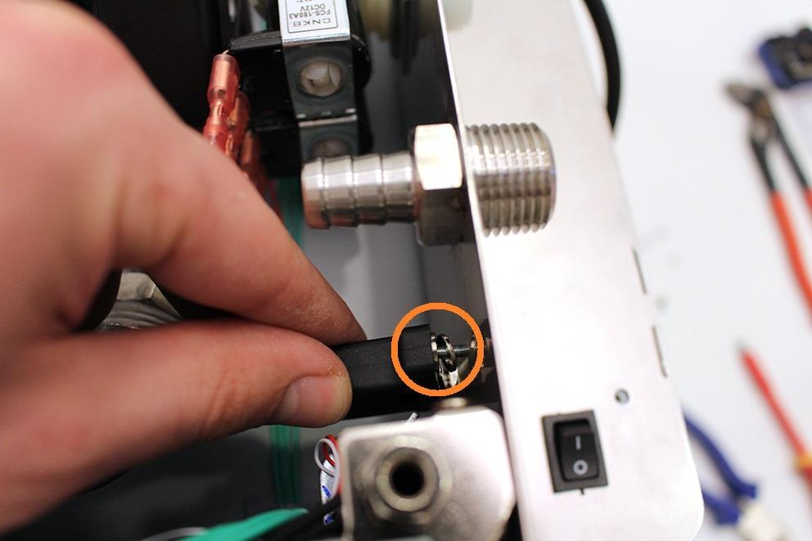

Loosen the indicated hose clamp and remove the high pressure hose from the fitting.

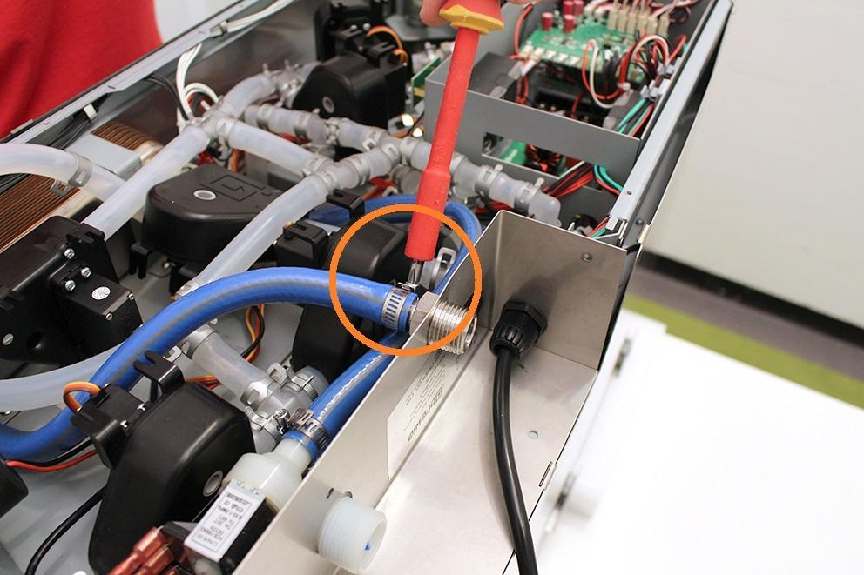

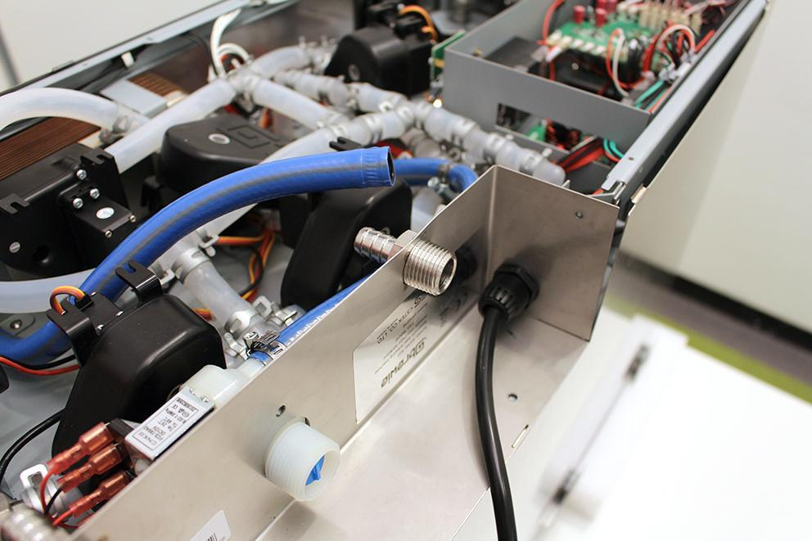

Pull up the sheetmetal part carefully and unplug the indicated plugs with a screwdriver.

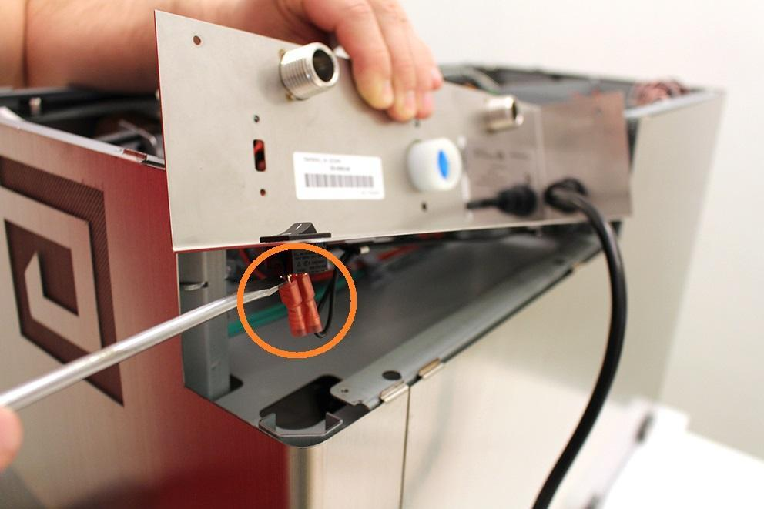

After you disconnected the plugs, push the switch on the indicated areas and you can remove it.

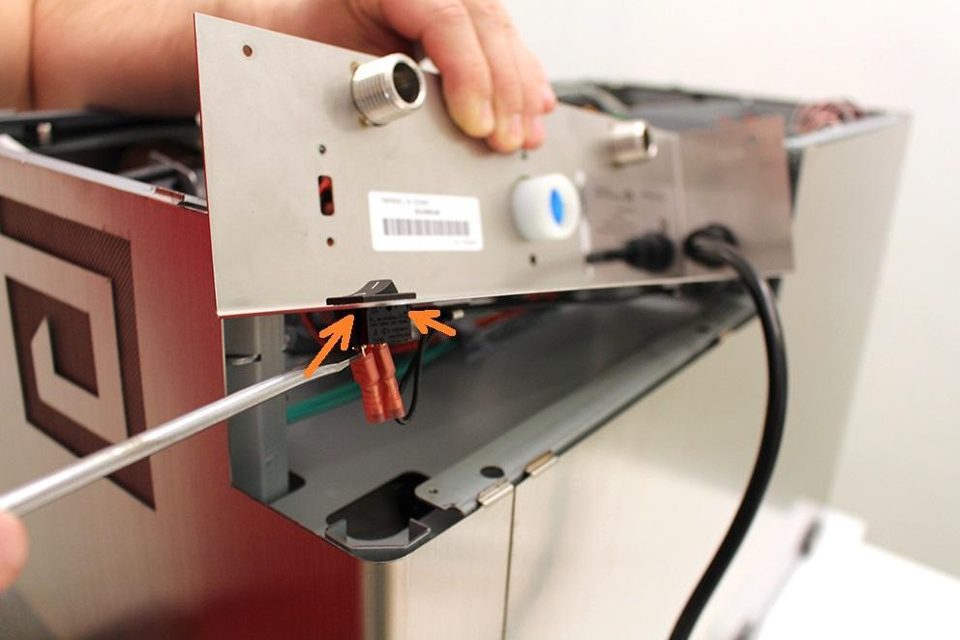

Reassemble consists of the same steps in reverse.

Make sure that the wort outlet hose clamp is in the proper angle. Otherwise you cannot reassemble the bottom sheetmetal.

